**Spring-Loaded**

**Pallet Positioner**

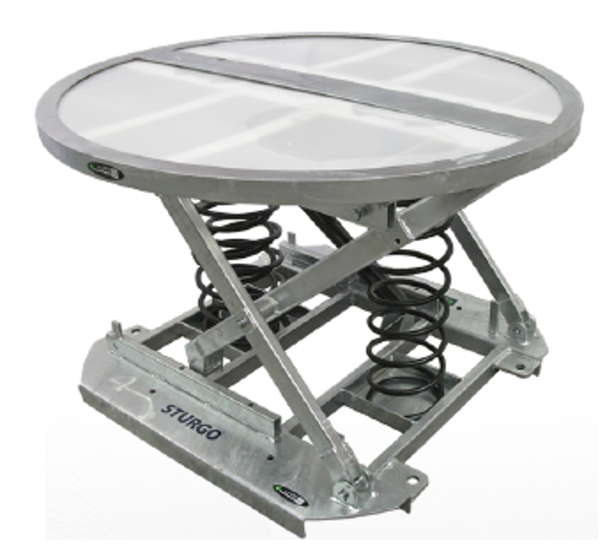



**Features & Benefits**

1. Simple, robust scissor lift mechanism
2. Heavy duty compression springs with shock

absorbers dampen vertical movement of load

1. Built in forklift pockets
2. Turntable top allows load rotation
3. Durable galvanised construction
4. Optional Rotation Lock allows top to be secured

in fixed position

1. Optional Adjustable Feet for uneven surfaces

and to allow pallet jack transportability

1. Modifications available: Alternative Springs,

Heavy Duty Castor Kit, Fixed Square Top

**Specifications**

**Model 16810072 - Pallet Positioner**

Platform Diameter: 1100mm

Height Range: 230mm (compressed) - 700mm

(extended)

Load Capacity: 2000kg

Unit Weight: 160kg

**Model 13860051 - Rotational Lock**

**Model 13860074 - Adjustable Feet**

**Usage**

Suited to any workplace where loading and

unloading palletised goods is required. Load height

is automatically adjusted as load is increased and

decreased, eliminating user strain related to

bending and lifting.